 Translated from Chinese (Simplified) to English - www.onlinedoctranslator.com
- Receiver wiring
The following diagram shows the output wiring sequence of the receiver; only the following two lines are needed.CH1/PPM, GND, VCC.
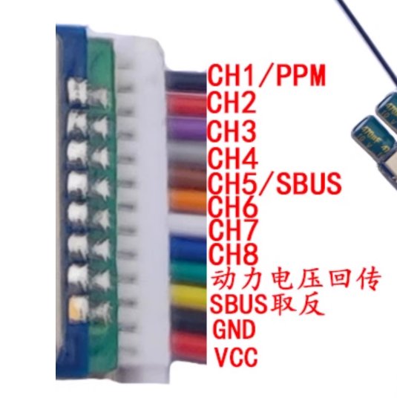
The receiverCH1/PPM, GND, VCCReceived in sequenceThe expansion board has 40 pins, GND, and 3V3 (in the middle row).As shown in the figure below.
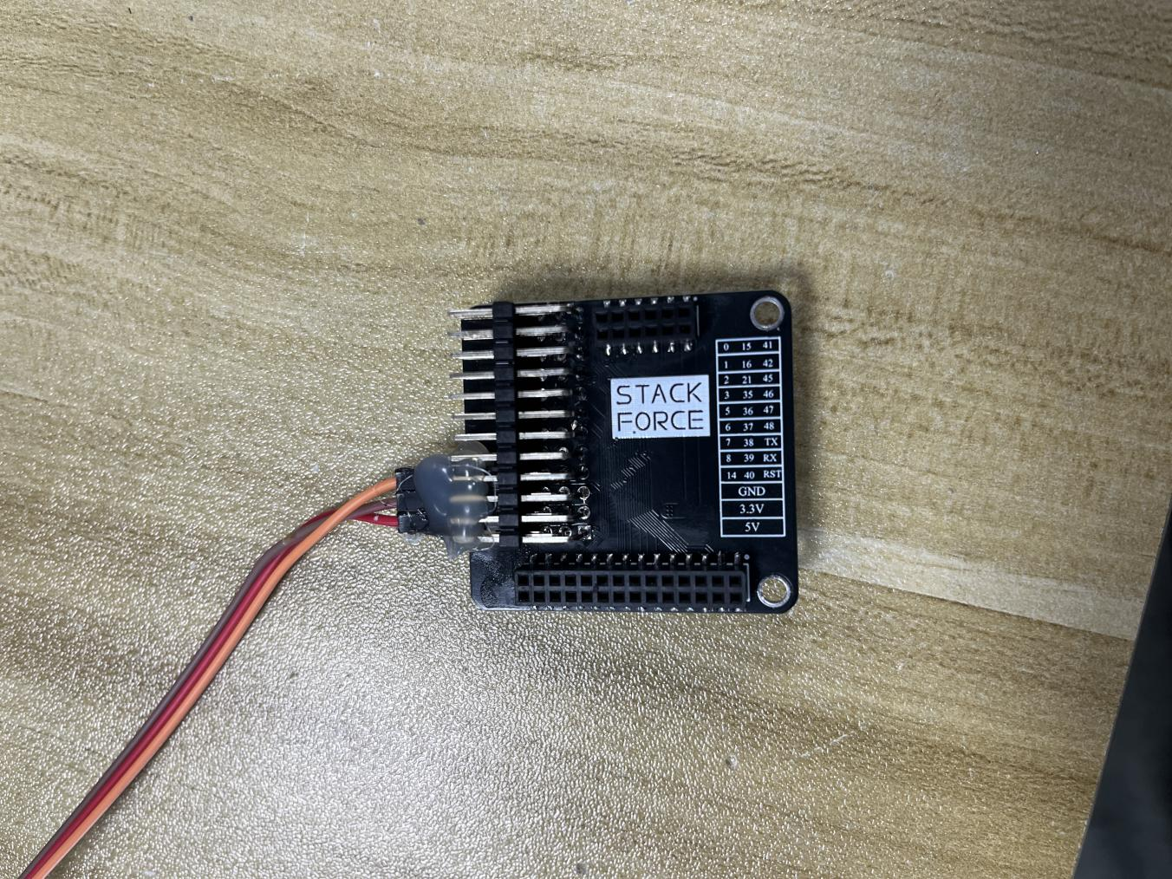
- Receiver and remote control frequency pairing
Before pairing frequencies, turn off the remote control, then power on and off the receiver three times within 10 seconds to enter pairing mode.The receiver lights up and goes out in one second.),ThenTurn the remote control enable switch down to enable signal transmission.,Pull the left joystick of the remote control down to its lowest position, then power on the remote control.That is, the frequency matching was successful.The receiver indicator light will turn off after successful frequency pairing.
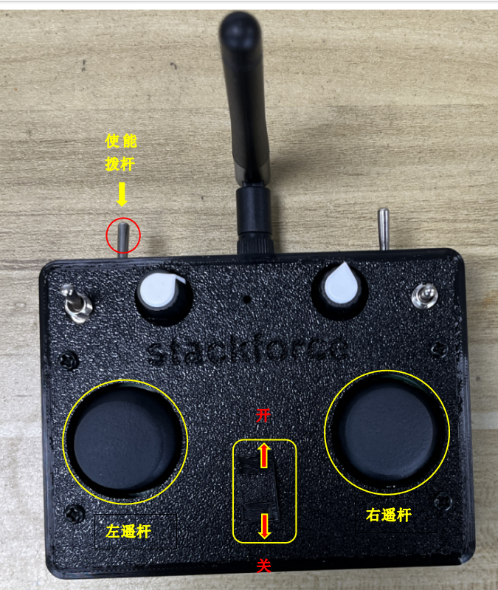

- Basic instructions for using the remote control
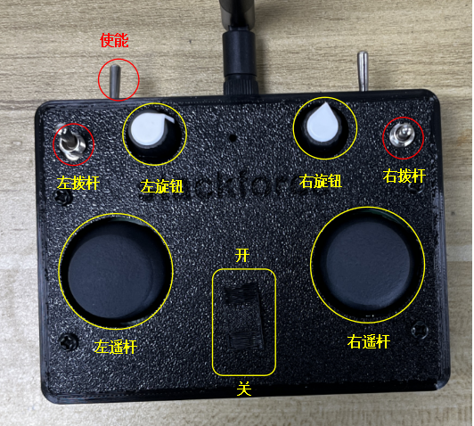
Enable leverDoes the remote control send a signal?
Left joystick (up and down direction)Controlling robot height
Left joystick (left and right directions)Control the height of both sides of the legs (Shoulder shaking needs to be turned on.)
Right joystick (up and down direction)Controlling the robot to move forward and backward
Right joystick (left and right directions)Controlling the robot to turn left and right
The left lever needs to be used in conjunction with the left knob.:whenTurn the left knob clockwise to the topWhen the left lever is moved down,Turn on the shoulder shake function; swipe up to turn it off..whenWhen the left knob is turned counterclockwise to the end,Swipe down to make the robot jump, swipe up to turn off jumping..
Right leverThe right lever has three positions: the top position disables the hub motor, the middle position enables the hub motor, and the bottom position activates the self-stabilizing mechanism.
Right knobAdjusting the balance bias
- Robot power-on operation
Pull the left joystick of the remote control to its lowest position, then power on the remote control.robotLegsSuspended and parallel to the ground,robotLegs should hang naturally to ensure smooth wheel rotation for calibration.,ThenOpen the robotpower supplyswitchAfter the hub motor calibration is complete, pull the left joystick of the remote control all the way up to reset the S3 chip on the main control board. Wait for the calibration to complete, and then...Left stickPull the lever all the way down to retract the robot's legs, then place the robot on the ground. Next, move the right lever to the middle position to start the hub motors. If the robot cannot maintain its balance, fine-tune the right knob on the remote control until the robot maintains its balance..If you don't understand the above steps, you can contact the technical staff in the group to watch the power-on operation video for the robot!
Important! Do not over-discharge the model airplane battery. You can use a multimeter to measure the battery voltage. The normal discharge range is generally 25-21V. If it drops below 21V, charge it promptly!

